*CREATE THE ATTENDENCE TABLE.
*INSERTING THE ATTENDENCE DATA IN TABLE.
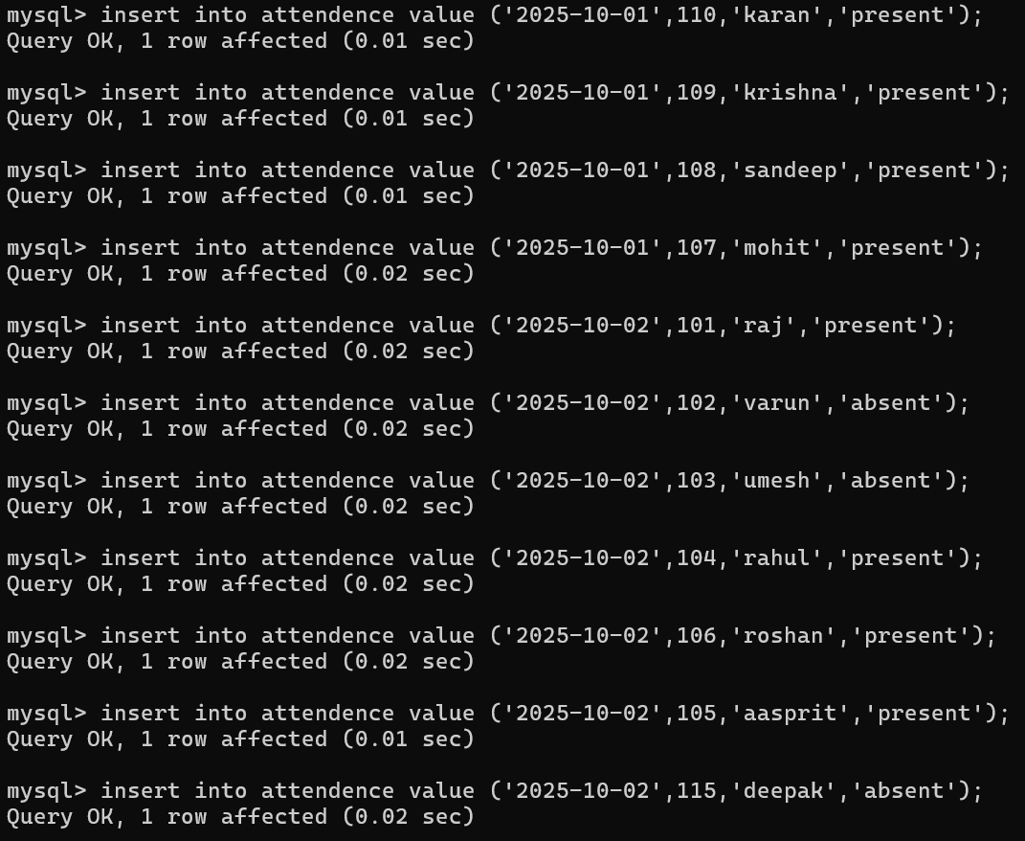
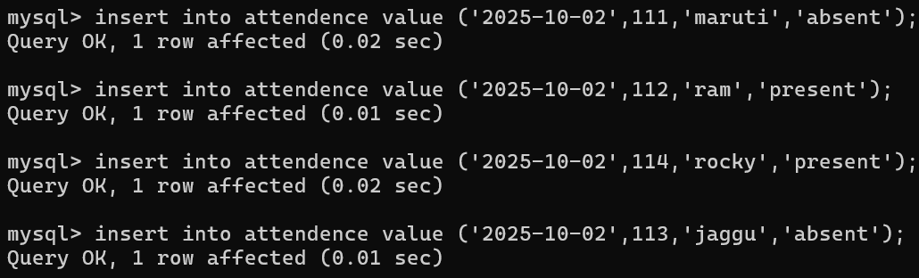
*STUDENT TABLE.
